5 STAR DOG TRAINING
KAMLOOPS, B.C.
YVON NE BABIJ
and
MARY ZACHARTOS
Together for the VERY FIRST TIME!

Kamloops, B.C.
Saturday May 12 and Sunday May 13
Outdoors on grass, camping available
DICK HART PARK, HEFFLEY
2 half day seminars and a 4 class fun match!
Limited working spots, Unlimited auditing
Yvonne Babij
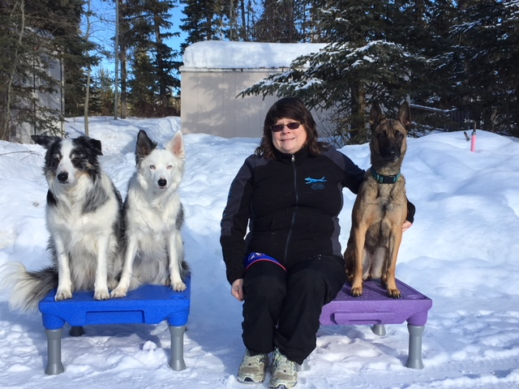
Yvonne Babij cannot remember a time when she wasn’t training or shaping an animal’s behaviour…be it a family pet, a bird in the campsite, a horse at the stockyards or what have you. In the 90’s Yvonne brought home her first Belgian Shepherd, Teaka, and due to Teaka’s versatile nature Yvonne sought out dog sports to enjoy with her. They tried CKC obedience with some success and they also enjoyed tracking, but Yvonne kept hearing about this new fad called agility. Needless to say, Yvonne sought out a trainer in the Vernon area that was offering agility lessons and got hooked! By the year 2000 she was totally committed to the sport and has worn many hats; from student to competitor, instructor to judge and now seminar presenter.
Over the years her dogs have earned 6 agility championships (ATCh) and her favourite game to play is Gamble.
Yvonne loves to teach her dogs to work at a distance and to perform the obstacles independent of her. They also enjoy a fair bit of success with verbal directionals and the verbal understanding of the obstacle names. Seminars are meant to be F.U.N for all and of course if you are not having fun, then you are doing it wrong!
Yvonne currently trains 2 Border Collies, Denim & Deuce and is bringing up a young Malinois named Scooby-Doo.

Mary Zacharatos
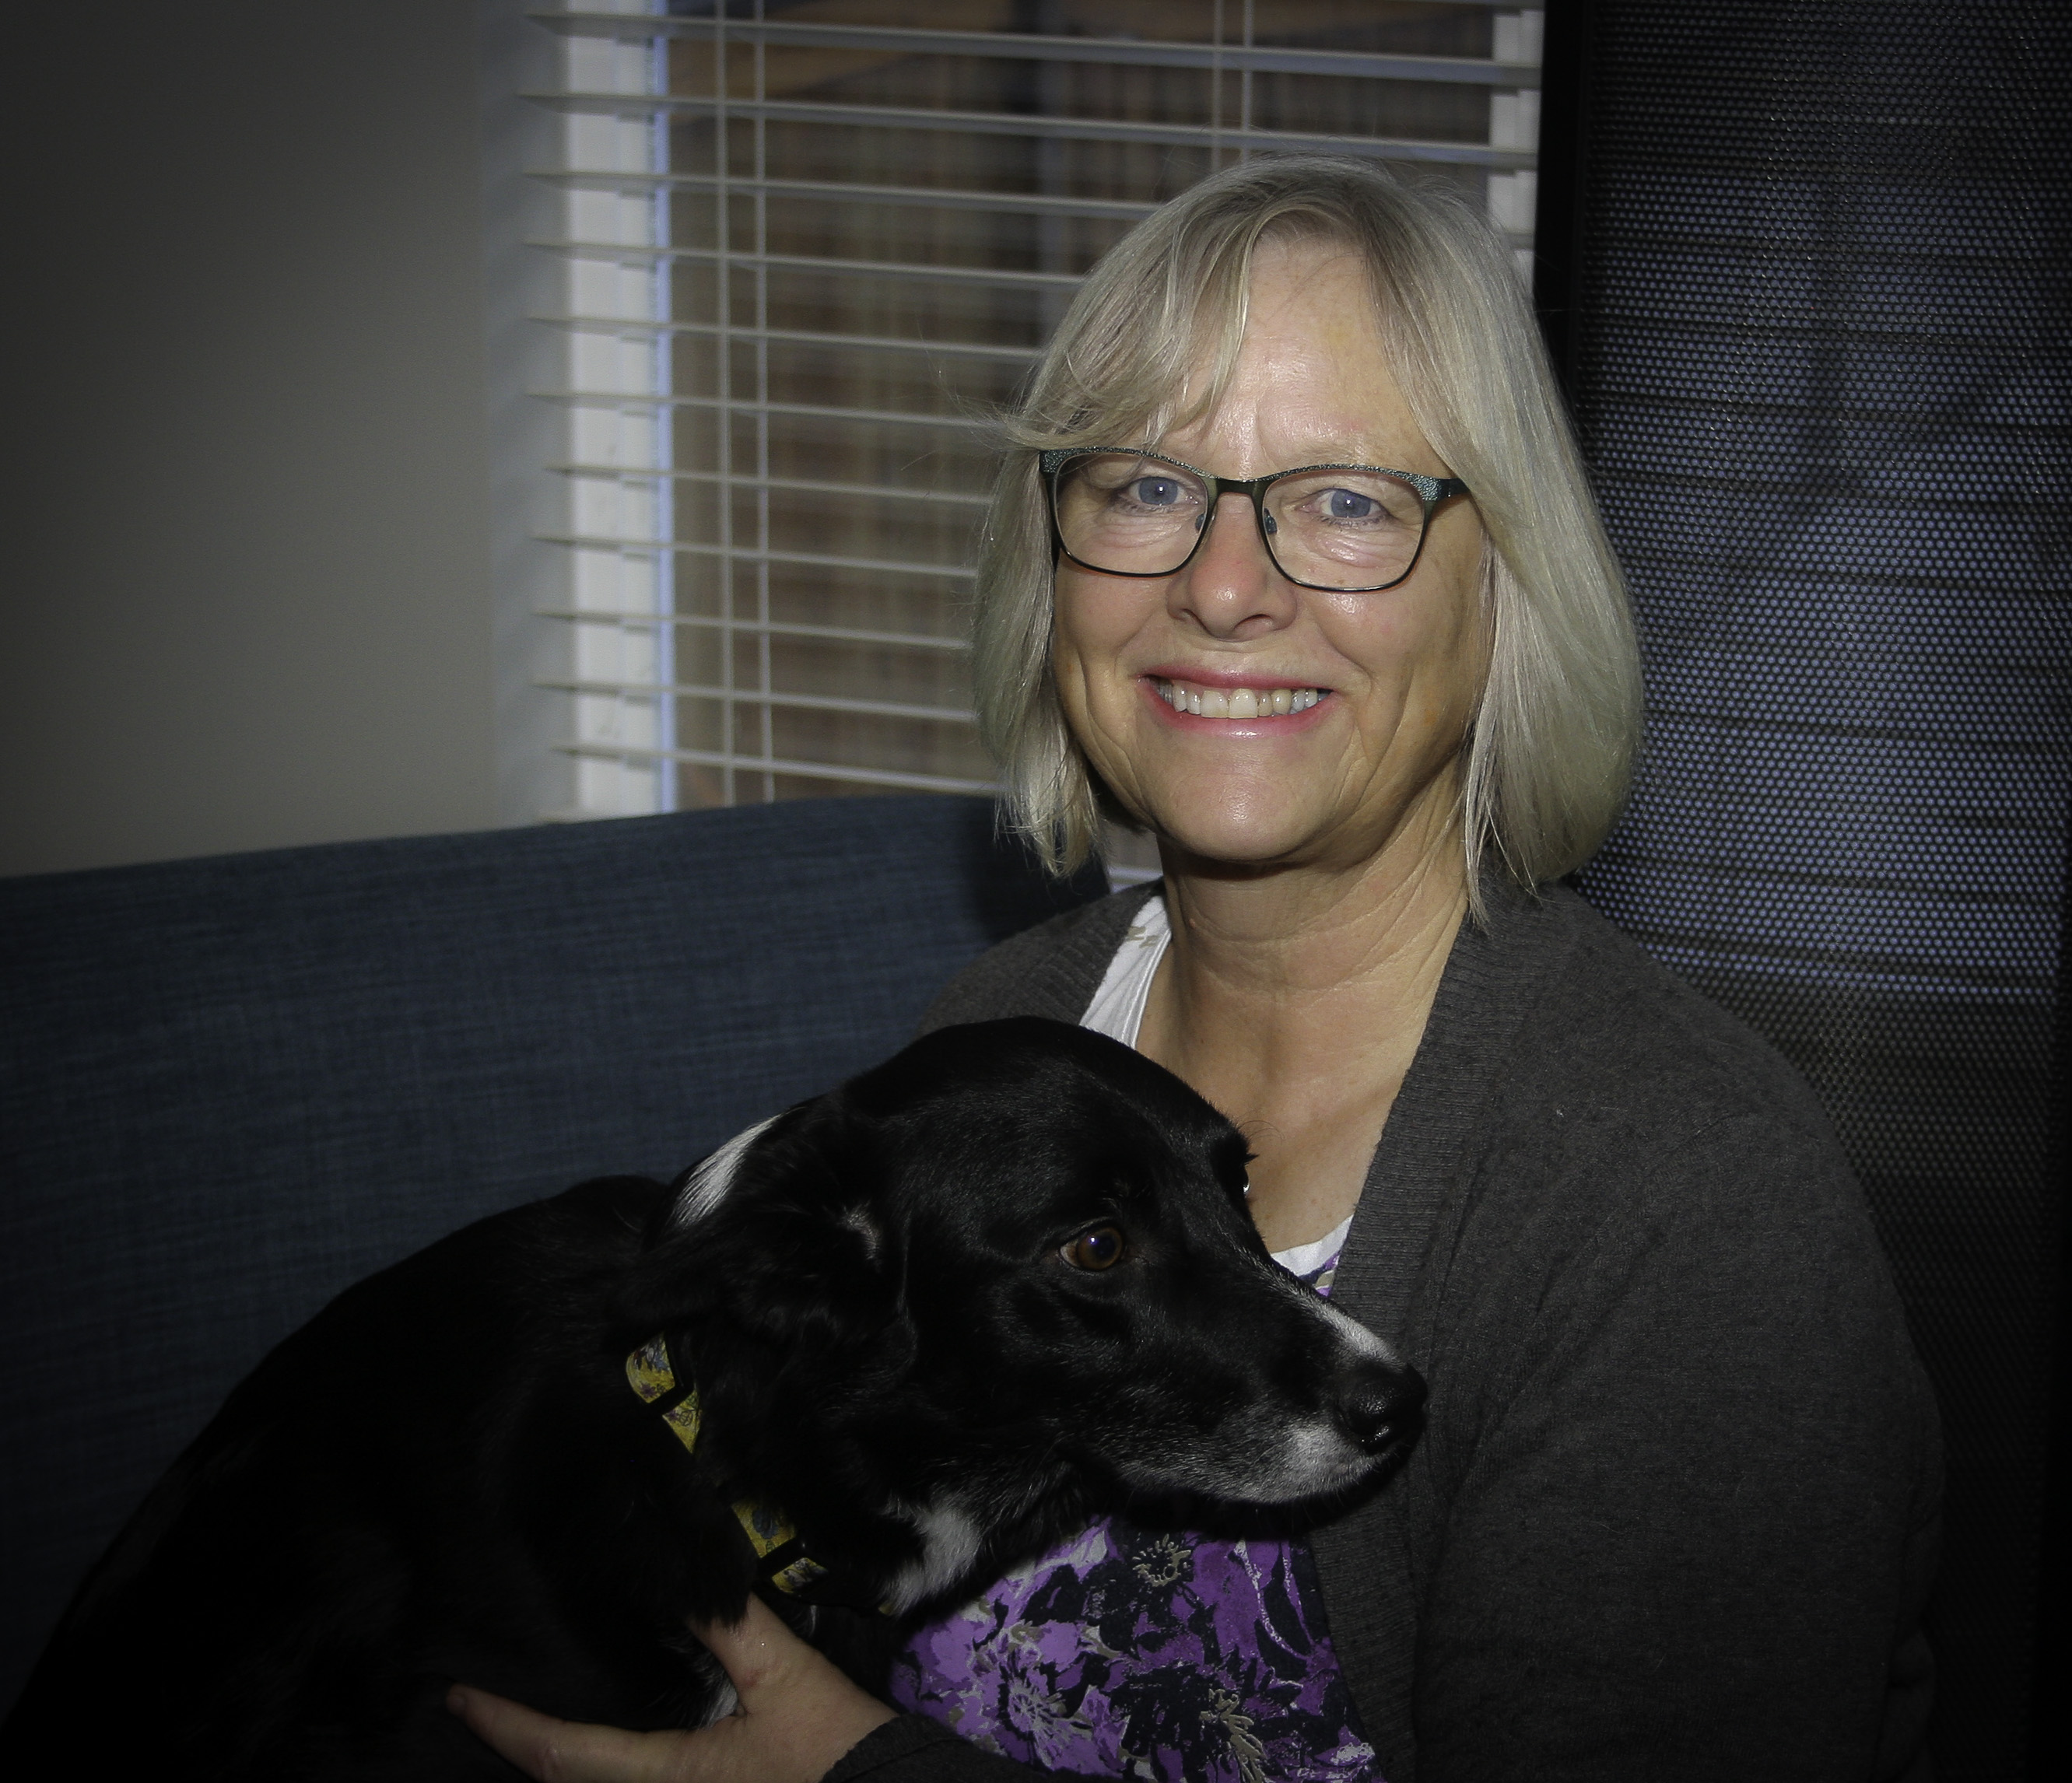

Mary has been involved in agility for more than 20 years. She got into dog training because of Duffy, Mary’s second dog and a very difficult West Highland White Terrier. He had severe behavior issues and through Mary’s love of learning positive training techniques, he overcame a lot of his issues and was able to compete in the sport of agility. He went on to win the BC Regionals three times and won the Canadian Nationals as well. Mary’s first border collie, Skye, was also a BC champion and a Canadian National champion.
Mary has been an AAC Masters judge for 15 years and has judged Regionals and National competitions as well as many local and not so local trials.
Mary owns and is head trainer of 5 Star Dog Training in Kamloops and currently trains and runs a 3 year old border collie, Charlee (also knows as Charlee, bad Charlee).
Mary continues to stay up to date with modern, positive dog training techniques by attending seminars and conferences and courses.

SEMINAR INFORMATION

Saturday – Yvonne seminar - distance skills 8:30 a.m. - 12:00;
Mary Seminar - handling skills 1:00 p.m. – 4:30 p .m.
Sunday Fun match (4 runs) starting 8:30 a.m. We should be finished by late morning/early afternoon

Working spots for Saturday’s seminars are limited will be awarded on a first come, first served basis. Preference will be given to people entering both morning and afternoon sessions.
These seminars and fun matches will be at the starters/advanced level. If your dog is more advanced, the instructors will adjust for your dog’s level.
Entries will be accepted by email or by mail, not over the phone.
Refunds will be issued only with a note from a vet or doctor.
There are unlimited auditing spots available and auditors are welcome to stay all day.
Dry camping is available for $10/night.
Site directions will be sent with confirmations.
Mary Zacharatos
5 Star Dog Training
pmzacharatos@shaw.ca 250-320-5787
YVONNE BABIJ and MARY ZACHARATOS
May 12 and 13, 2018
Hosted by 5 Star Dog Training
ENTRY FORM
Name: ____________________________________________________________
Phone :_______________________________ cell:_________________________
Address:_______________________________City: ________________________ Prov:_______________ Postal Code:____________________________________
Email:_____________________________________________________________
Dog’s Name:_______________ sex: _____age: _____ breed:_________________

Training goals for this seminar_________________________________________
Training/Competing Level of dog _______________________________________
tic
 | Working spot Yvonne distance seminar  Saturday morning 8:30 – noon | $80.00 plus tax | $84.00
 | Working spot Mary handling seminar  Saturday afternoon 1:00 – 4:30 p.m. | $80.00 plus tax | $84.00
 | BOTH SEMINARS 10% DISCOUNT $160 – 10% (PLUS TAX) | $144.00 plus tax | $151.20
 | Sunday Funs Match $10 per run  Gambler 1 _____ Gambler 2_______  Jumpers 1 ______ jumpers 2 _______ | $10.00 plus tax | $10.50
 | Pre- enter 4 or more $9.00 each plus tax. This is per handler, so if you have 2 dogs and enter 4 or more runs, then $9.00 per run. Same day (Sunday) add ons accepted at $10/run.  Gambler 1 _____ Gambler 2_______  Jumpers 1 _____ Jumpers 2 _______ | $9.00 plus tax | $9.45
 | Auditing spot Saturday seminars $20.00 plus | $20.00 plus tax | $21.00
 | TOTAL ENTRY FEE INCLUDED

SPOTS AWARDED ON A FIRST COME/FIRST SERVED BASIS.

Cheques payable to: 5 STAR DOG TRAINING
Mail entry form/cheque to: 5 Star Dog Training, 229 Chetwynd Drive, Kamloops, B.C. V2H 1L7
Or email entry form to pmzacharatos@shaw.ca and pay by e-transfer to maryzacharatos@shaw.ca
THE WAIVER (NEXT PAGE) MUST ACCOMPANY THIS ENTRY FORM.
5 Star Dog Training
www.fivestardogs.ca
Handler Information:
Name:_______________________ phone:_____________ email:_______________________
Address: ________________________ City:_______________ Postal Code: _______________

IF BRINGING A DOG:
Dog Information:
Dog’s Name: ___________________ Birth Date: _____________ Breed:_________________

By signing this document you will waive certain legal rights, including the right to sue.
Please read carefully
Re: Dog Training Events to be held through 5 Star Dog Training
To: 5 Star Dog Training and its Executive, Directors and Members;
AND TO: The Instructor(s) all of whom are hereinafter collectively referred to as “the Releasees”

I am aware that the event has, in addition to the usual dangers and risks inherent in the sport of dog training, such as being bitten, further dangers and risks including but not limited to slipping, collision with other participants or instructors or spectators, and I freely accept and fully assume all such dangers and risks and the possibility of injury, death or property damage to me, my next of kin or my dog and the losses, costs and damages which may result there from.
That I freely accept and fully assume all such dangers and risks associated with being a participant of dog training events being held by 5 Star Dog Training, including but not limited to the possibility of injury, death or property damage to me, my next of kin or my dog and any losses, costs and damages which may result there from.

In consideration of the Releasees accepting my application for Classes: I HEREBY AGREE AS FOLLOWS:
- TO WAIVE ANY AND ALL CLAIMS that I may have against the Releasees;
- TO RELEASE THE RELEASEES FROM ANY AND ALL LIABILITY for any loss, damage, injury or expense that I may suffer or that my dog may suffer or that my next of kin may suffer as a result of my participation in the dog training event due to any cause whatsoever, INCLUDING ANY NEGLIGENCE ON THE PART OF THE RELEASEES;
- TO HOLD HARMLESS AND INDEMNIFY THE RELEASEES from any and all liability for any property damage, personal injury or death to any third party, or their dog, resulting from my participation in the dog training event;
- THAT this Release of Liability shall be effective and binding upon my heirs, next of Kin, executors and administrators and assigns in the event of my death.
I am of the full age of nineteen (19) years and I HAVE THE LEGAL AUTHORITY to sign on behalf of any next of kin which may accompany me to the Classes and I HAVE READ AND UNDERSTOOD THIS RELEASE OF LIABILITY PRIOR TO SIGNING IT, and I am aware that by signing this Release of Liability I am waiving certain legal rights which I or my heirs, next of kin, executors, administrators and assigns may have against the Releasees.

Dated the _____ day of ________________ 20 ______
___________________________ ________________________
Signature of Participant Parent or Guardian
Must be signed by the participant or parent or guardian before the participant will be permitted to participate in dog training events.

